**Installation Guide for**

**J.A.W.S. Procurement Software**

**Version 1.0.1 - 27 November 2022**

**J.A.W.S. Procurement LTD ||** [**inquiry.jaws@support.ca**](mailto:support.jaws@inquiry.ca) **||+1(800)-900-3001|| www.jawsltd.ca**

**Table of contents**

**1. Introduction** **3**

1.1. Purpose of this document

1.2. Identification

**2. Installation** **Plan 4**

2.1. Prerequisites

2.3. Installation Procedure

2.4. Post-installation and Configuration Procedure

**3.** **Additional Information 9**

3.1. Reference Documents

3.2. Contact information

**4. Troubleshooting** **9**

# **Introduction**

In this installation guide, we have set detailed steps and requirements to deploy our application J.A.W.S. Procurement system. This document alone is sufficient for the installation and in case problems arise, please contact us (contact information below).

## 1.1. Purpose of this document

The purpose of this document is to guide the users through detailed steps and requirements to deploy our application. This guide covers the installation of the whole system and its requirements, including migrating to the application from the code. The application is J.A.W.S. procurement system, designed to supply all types of businesses.

## 1.2. Identification

This installation guide applies to J.A.W.S. Procurement software version 1.0.1 release 0.6. This document follows the ISO 9001 standards.

# **Installation Plan**

2.1. Prerequisites

Prior to the installation of the software, the following requirements must be respected and executed in order to guarantee a successful launch of the application.

* Operating system: Microsoft Windows 8 (or later versions)**/**Apple macOS Big Sur (or later versions).
* Hardware requirements:
* Web browser
* Minimum processor speed of 1.4 GHz
* 32 or 64-bit processor
* 4 GB or greater of RAM
* Minimum 64 GB of hard disk space
* Software requirements:
* PHP language installed
* Web development IDE

2.2. Installation Procedure

1. PHP language installation
2. Follow the given link - <https://www.php.net/downloads.php>
3. Select the option applicable for the operating system used. Example: For Microsoft Windows:-

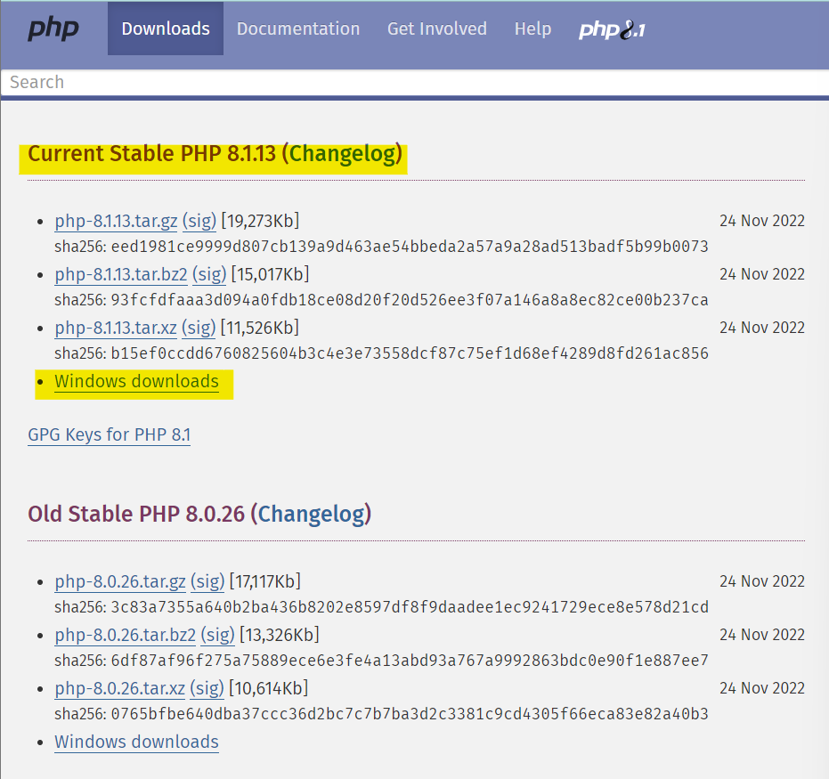

1. Select the zip file under the “Thread Safe” category:

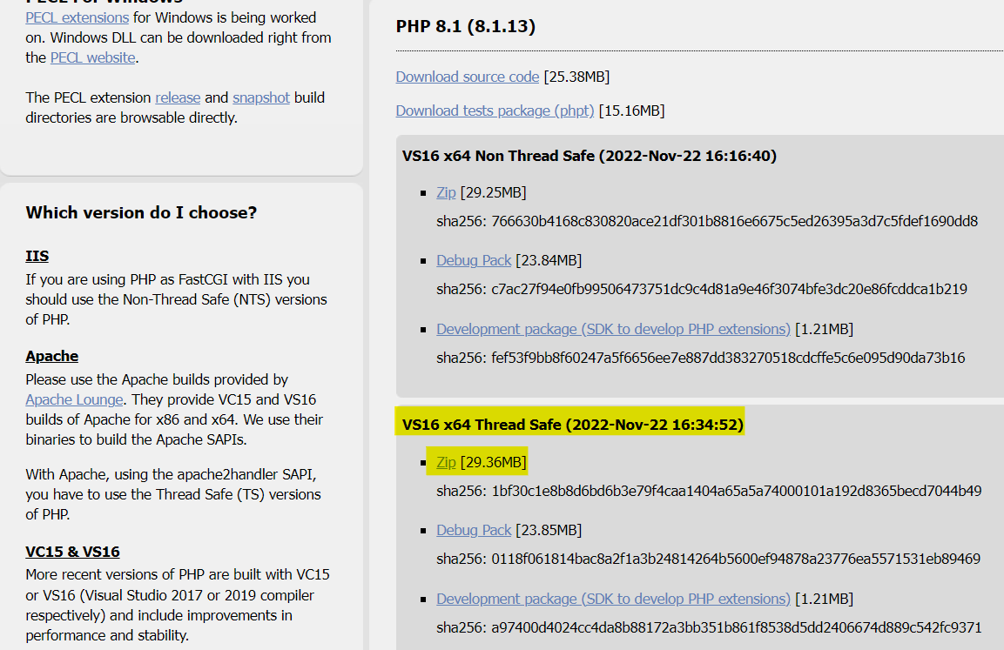

1. Extend the zip file to the local disk
2. Copy the path of the file extended
3. Open “Edit the System Environment” and click “Environment Variables”
4. Select “Path”, click on “New” and paste the file path

2) Web development IDE installation (most suitable IDE is “Visual Studio Code”)

1. Follow the given link - <https://code.visualstudio.com/download>
2. Select the download option suitable for the operating system used. Example: For Microsoft Windows:-

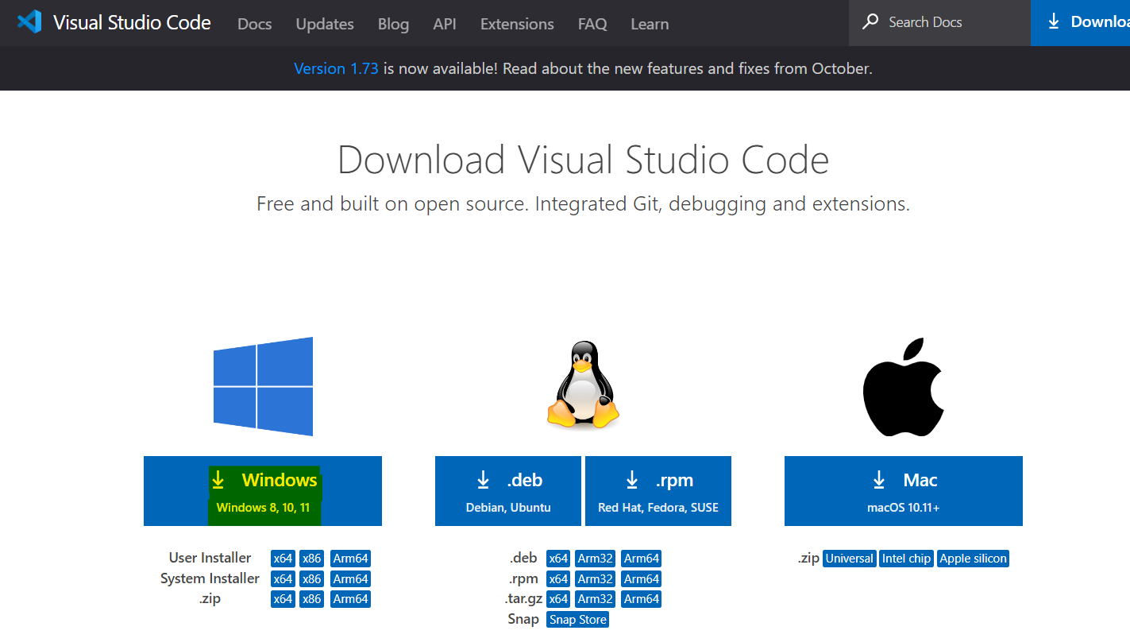

1. After the IDE has been installed, open it and install the PHP language extensions:

i) Select “Extensions”:

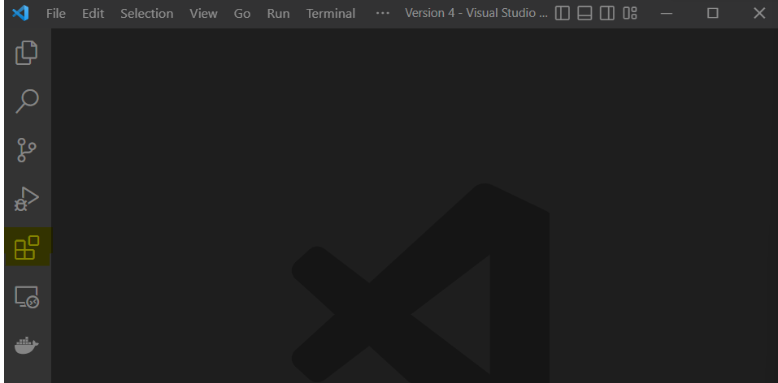

ii) Search PHP then install “PHP Intelephense” and “PHP Server”:

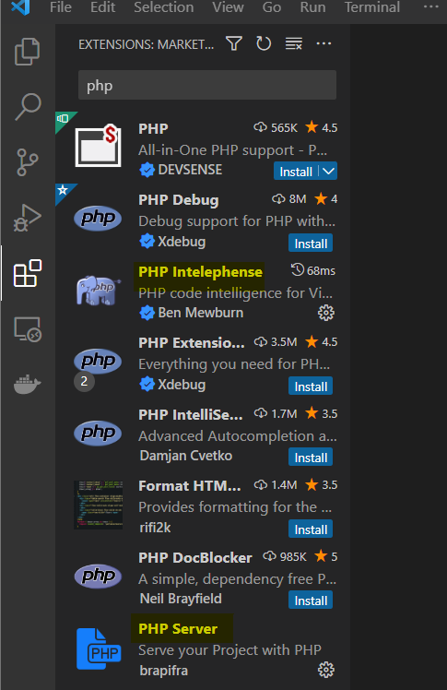

2.3. Post-Installation and Configuring Procedure

1. Import the application file from downloads. The link for the source files of the application can be found below:

Application file: *jaws.file.download.ca*

1. Run the website code on the IDE installed:
2. Select “File” then select “Open folder”:

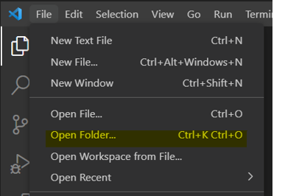

1. Select the downloaded folder
2. Click on the first .php file
3. Go to the code then right click and select “PHP Server: Reload server”:

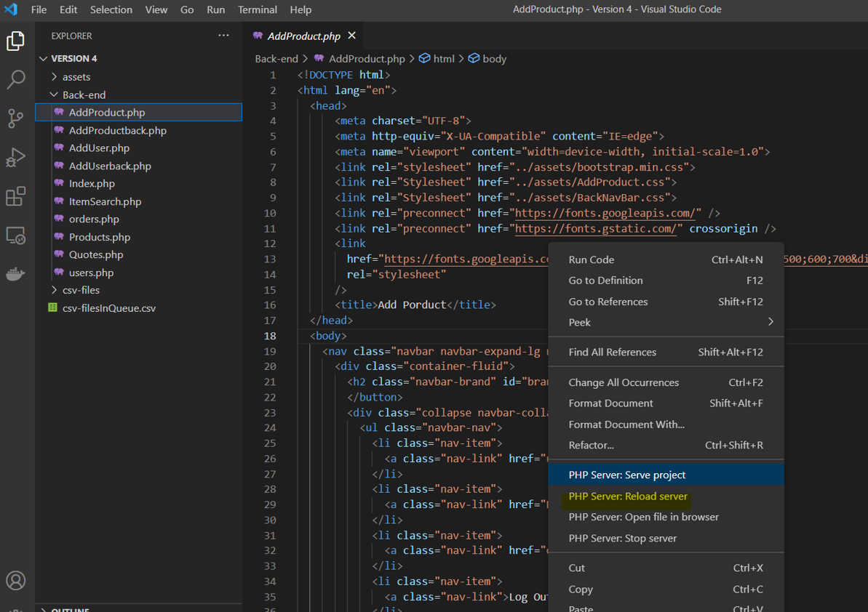

# **Additional Information**

3.1. Reference Documents

| **Title** | **Description** |
| --- | --- |
| User Guide | Guide on how to use the website and its functionalities. |

3.2. **Contact Information**

In case problems arise while installing the application, contact us:

* By email, at inquiry.jaws@support.ca. Please include your company ID as well as your employee ID, name and contact.
* By phone at +1(800)-900-3001, ext. 3000. This line is operational Monday until Friday from 7a.m. until 5p.m., and Saturday and Sunday from 9a.m. until 2p.m..

# **Troubleshooting**

In this section, we help users fix common issues that may arise.

While installing PHP and setting up the path environments, in case the IDE shuts down then restart the computer.